**Kipchakpayev Madiyar IS-1812k**

**Part 1. Customer Brief (10%)**.

**Welcome to Bookshop!**

Bookshop is an online bookstore with a mission to financially support local, independent bookstores.

We believe that bookstores are essential to a healthy culture. They’re where authors can connect with readers, where we discover new writers, where children get hooked on the thrill of reading that can last a lifetime. They’re also anchors for our downtowns and communities.

As more and more people buy their books online, we wanted to create an easy, convenient way for you to get your books and support bookstores at the same time.

If you want to find a specific local bookstore to support, [find them on our map](https://bookshop.org/pages/store_locator) and they’ll receive the full profit off your order. Otherwise, your order will contribute to an earnings pool that will be evenly distributed among independent bookstores (even those that don’t use Bookshop).

We also support anyone who advocates for books through our [affiliate program](https://bookshop.org/affiliates/profile/introduction), which pays a 10% commission on every sale, and gives a matching 10% to independent bookstores. If you are an author, a website or magazine, have a bookclub, an organization that wants to recommend books, or even just a book-lover with an Instagram feed, you can sign up to be an affiliate, start your own shop, and be rewarded for your advocacy of books. Bookshop wants to give back to everyone who promotes books, authors, and independent bookstores!

By design, we give away over 75% of our profit margin to stores, publications, authors and others who make up the thriving, inspirational culture around books!

We hope that Bookshop can help strengthen the fragile ecosystem and margins around bookselling and keep local bookstores an integral part of our culture and communities.

Bookshop is a benefit corporation - a corporation dedicated to the public good.

**Do you ship to Canada or Internationally?**

Bookshop.org only ships to the US, but we do have [Bookshop UK](https://uk.bookshop.org/) and [Bookshop Spain](https://es.bookshop.org/) available for those regions.

We do hope to help support bookstores all over the world in the future.

**How do I report a problem with the website or my order?**

[Contact Us](javascript:%20void(0);)

**How do I return an order?**

If you have received damaged, defective, or incorrectly shipped merchandise you may return it within 14 days of the delivery date for a full refund of the cost of the books returned including initial shipping costs. To ensure your package is returned correctly please include the return slip included at the bottom of your paper receipt. Return the package to the address indicated below and include and display the order number prominently on the slip and the packaging. Return postage is to be covered by the sender. If you have any further questions regarding your return please reach out to: [bookshop@bookshop.org](mailto:bookshop@bookshop.org).

**Mail to:**

**Bookshop LLC**

**Ingram Customer Returns Center**

**1210 Ingram Drive**

**Chambersburg, PA 17202**

**How does Bookshop work with independent bookstores?**

Bookshop supports indies in two ways: 10% of regular sales on Bookshop.org are added to an earnings pool that is evenly divided and distributed to independent bookstores every six months.

Stores that are affiliates, who sell books online using Bookshop (by sharing links their Bookshop link on social media, email newsletters, or on their websites) earn 30% of the cover price on any sales they generate, without having to do the work of keeping inventory, picking, packing, shipping or handling complaints and returns. (30% of the cover price is the entire profit margin - Bookshop doesn’t earn money off bookstore sales, all profits go to the store.)

All orders are fulfilled through Ingram.

**How does Bookshop promote local bookstores?**

Every receipt we email customers informs them about the bookstores near them.

If a Bookshop customer opts in, their local bookstore will be given their email address for direct marketing.

Affiliate stores can create recommendation lists (staff picks, etc) on Bookshop, boosting their visibility and earning a commission on every sale generated from the list.

**If I’m an affiliate, do I have to disclose that on my website, newsletter or social media posts?**

Yes. Whenever a link is used on your website that results in a commission, you must disclose this information to site visitors, according to FTC rules. We suggest adding something like: “Disclosure: I am an affiliate of Bookshop.org and I will earn a commission if you click through and make a purchase.” to your website or post.

About the project

***The ask:***Build an e-commerce website and design the experience for London’s neighbourhood bookshop — reflecting their ‘small shop’ appeal, great customer service and highly curated book selection.

***Timeframe:***This was a concept project completed over a 2 week sprint, during our third week into the UX Design course at GA.

***My role:***Sole UXerinvolved in completing all phases from research to design and delivery of the final website.

My design approach

I used the double diamond UX approach for designing an e-commerce solution involved four distinct phases:

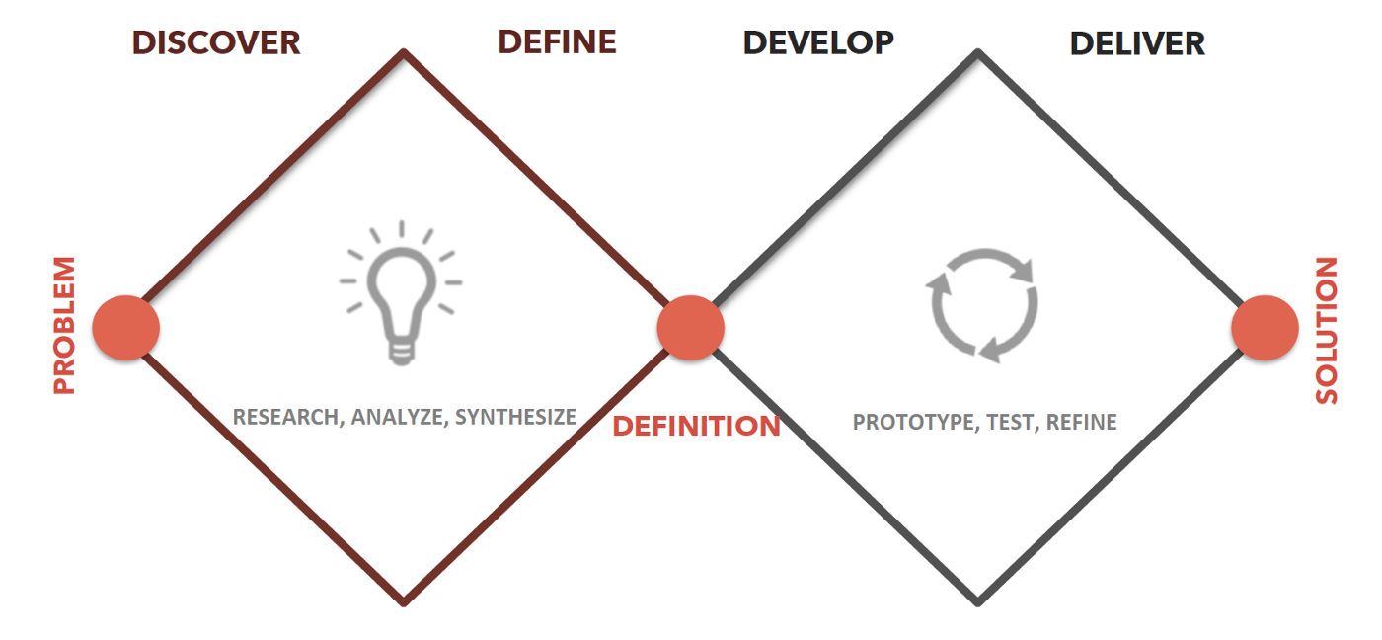

1. **Discover**— Conducting research on users, competitors and the market
2. **Define** — Synthesising and analysing our research findings and defining the information architecture of the website
3. **Develop** — Building a website prototype based on our user persona and conducting user tests
4. **Deliver**— Iterating several times based on user testing insights and refining our final prototype

Market research insights

In an age where Amazon’s e-books have revolutionised the way we read, our research has revealed that physical bookstores and paper books are not dead.

*In fact, e-book sales are falling while sales of paper books grew by 7% in 2016 — and the shift is being driven by younger generations.*

**Independent bookstores are thriving**

They’re the places where you now drop in for the latest paperback, listen to a reading from a favorite author or find a unique gift for a special friend.

And this is good news for a local bookstore, Bookworm Books, that support the local community through their staff hires and book sales.

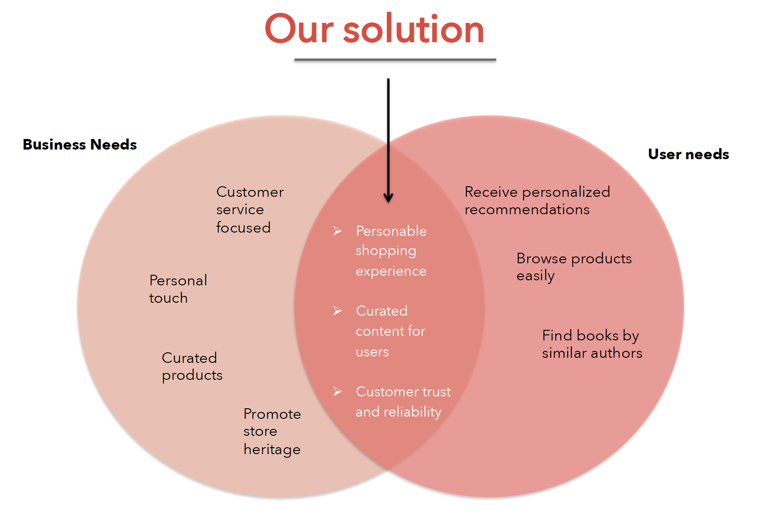

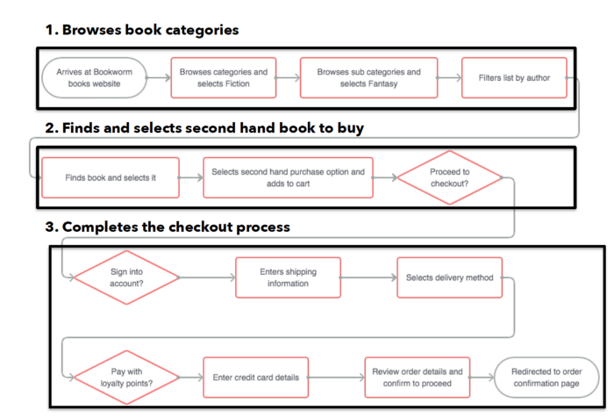

**Part 2. MVP features 10%**

**Have you ever felt at a loss about which features to include in your minimum viable product (MVP)? Have you ever wanted to build a strategy to help you choose the perfect features for your minimal viable product? The lean startup methodology can help you figure out what minimum viable product development should look like. If you can**[**find and hire good software developers**](https://steelkiwi.com/blog/how-to-find-and-hire-a-python-django-development-company/)**, they can help you figure out what features to include even faster.**

**We’ve built numerous MVPs and want to share our experience helping our clients choose the core features for their MVP design to**[**make their product work**](https://codingsans.com/blog/app-engagement-habit-forming-apps)**.**

**WHAT DOES MVP MEAN?**

**Many people have only a vague understanding of what an MVP is. What does MVP mean? An MVP definition goes like this: It is a product with minimum features that’s built with the least possible effort to learn as much as possible from it. Building an MVP involves specific product management steps we list in this article.**

**WHY IS CHOOSING FEATURES FOR AN MVP TRICKY?**

* **there’s competition**
* **clients have their own expectations**
* **limited budget**
* **limited time**

**An MVP isn’t about features alone. It’s about your users as well, which is where user-centered development comes in.**

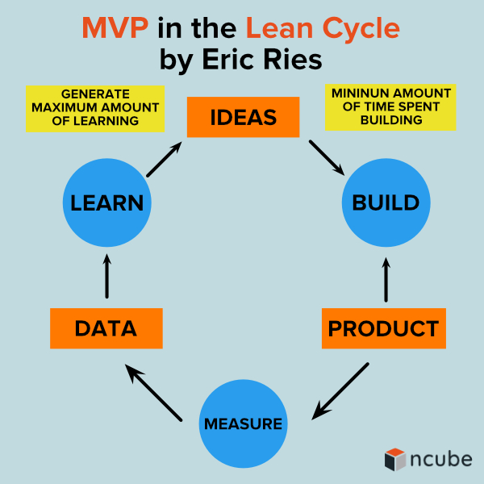

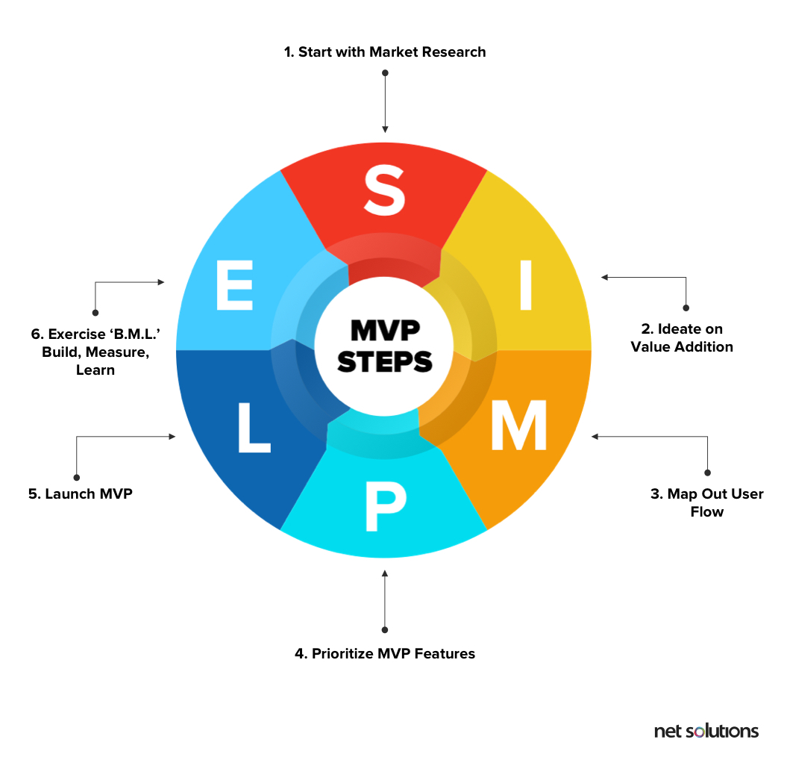

Low fidelity digital wireframes – Mockups

Low-fidelity wireframes act as the initial blueprints for web pages and app screens.

They help your stakeholders focus on a page’s key purpose and functionality by deliberately excluding any specific details like colours, fonts, logos, and exact sizing – all of which can be added later!

Instead, wireframes use basic shapes, image placeholders, and generic ‘lorem ipsum’ text to represent – in greyscale – the draft layout for future designs.

**How to create a low fidelity wireframe with Moqups?**

Edit and customize our ready-to-use templates to fit the needs of you and your team. Just click on any example below to open the Moqups app – and get right to work!

[[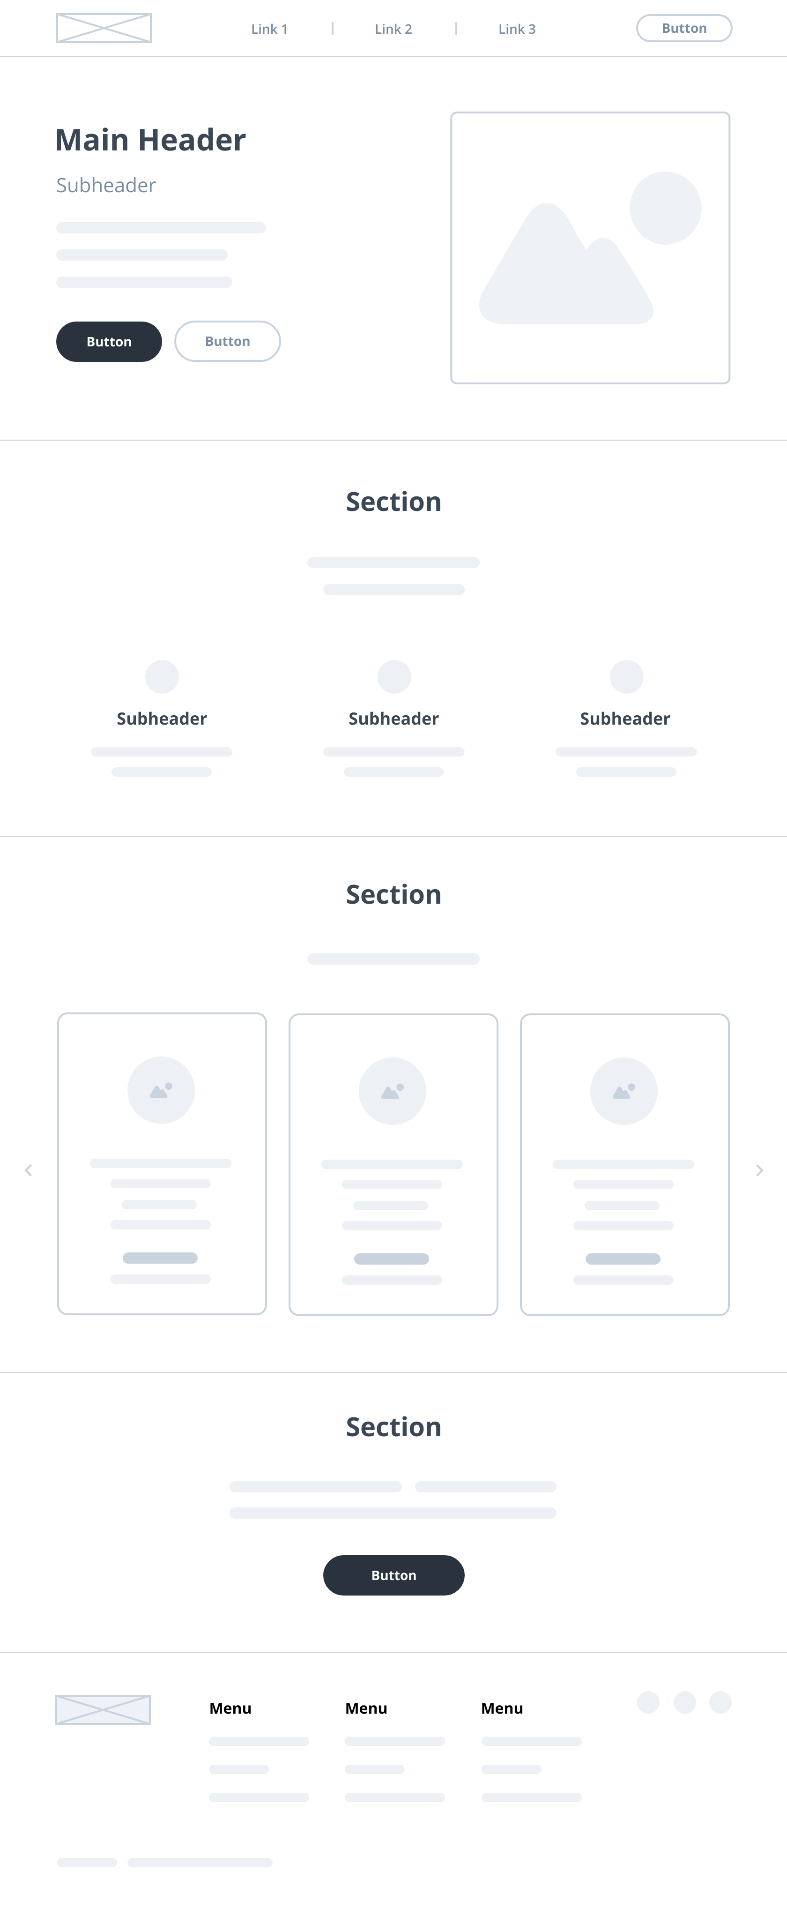](https://app.moqups.com/import/project/pWqAUMFW9J)](https://app.moqups.com/import/project/pWqAUMFW9J" \o "Low Fidelity Wireframe Template)

No credit card required

**Iterate fast with low-fidelity wireframes**

Every member of the team – even non-designers – can experiment with basic wireframes, reconfiguring elements on the page, or even proposing new approaches. That results in better solutions and faster iteration.

**Capture ideas and inspiration**

The simplicity of lo-fi wireframes is what makes them so useful. They’re easy to create – so you can quickly get ideas out of your head, share your vision, and build consensus.

**Save development cost and improve performance**

The best way to minimize development cost is to explore competing concepts early in the game. Last minute reversals result in lost momentum and costly delays. Our low-fidelity wireframe template helps your team compare different approaches – and hear all voices – before your organization commits precious resources to a final design.

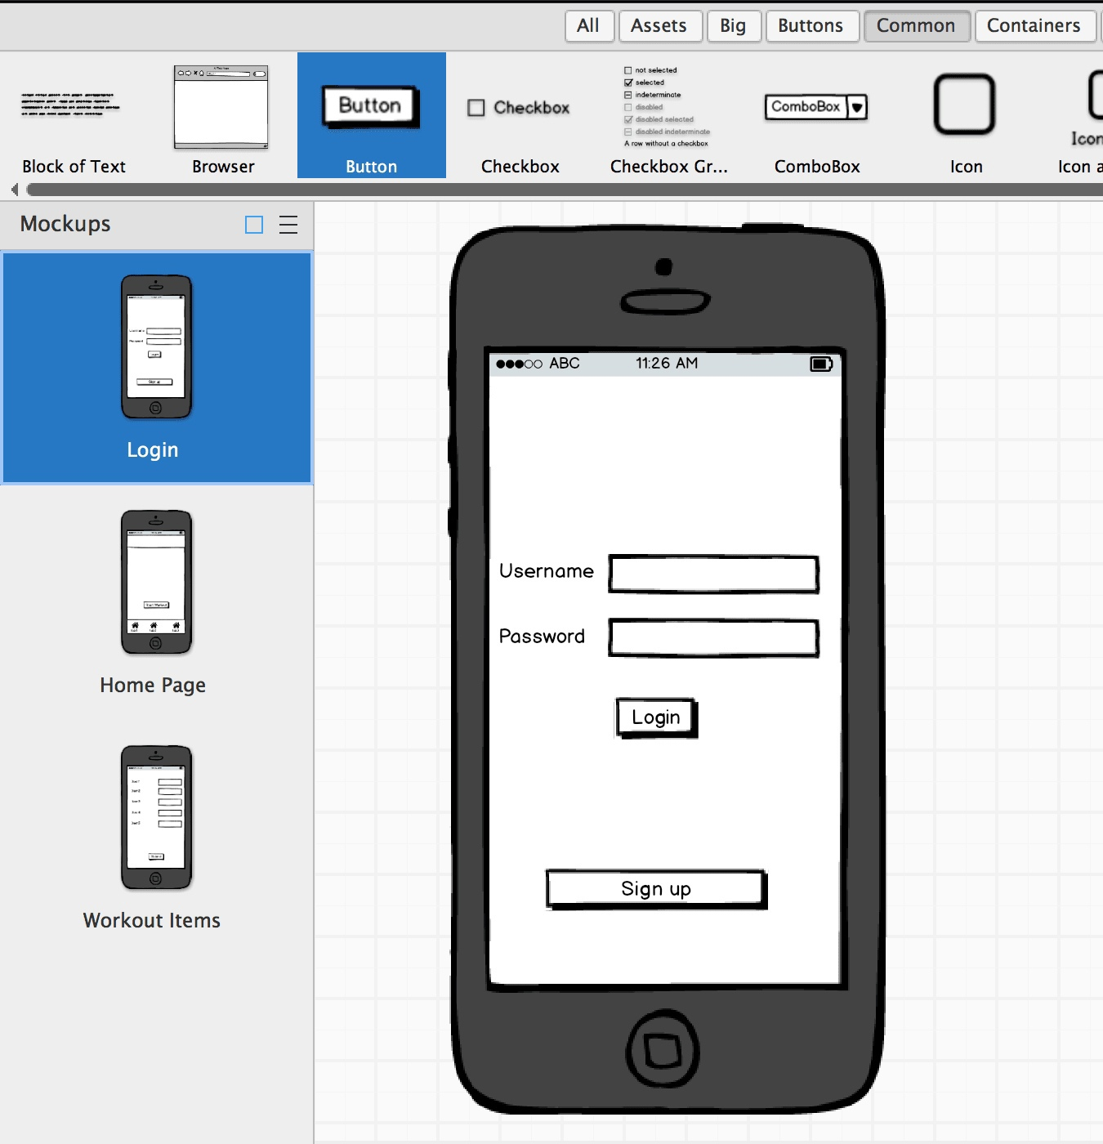

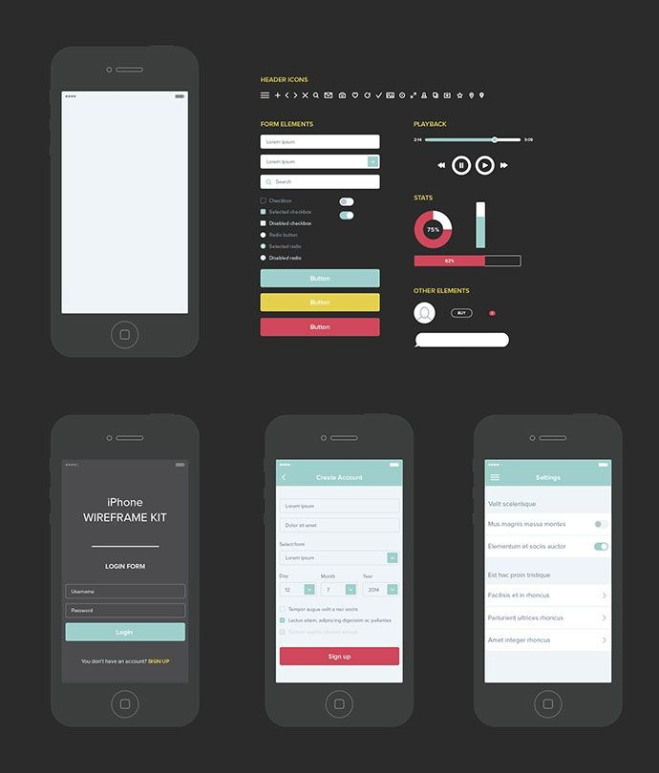

**Part 4. Development of the product** 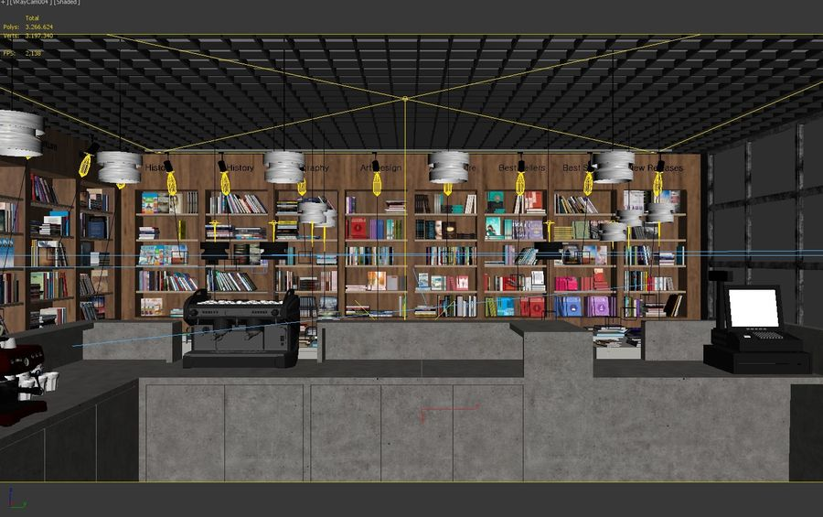

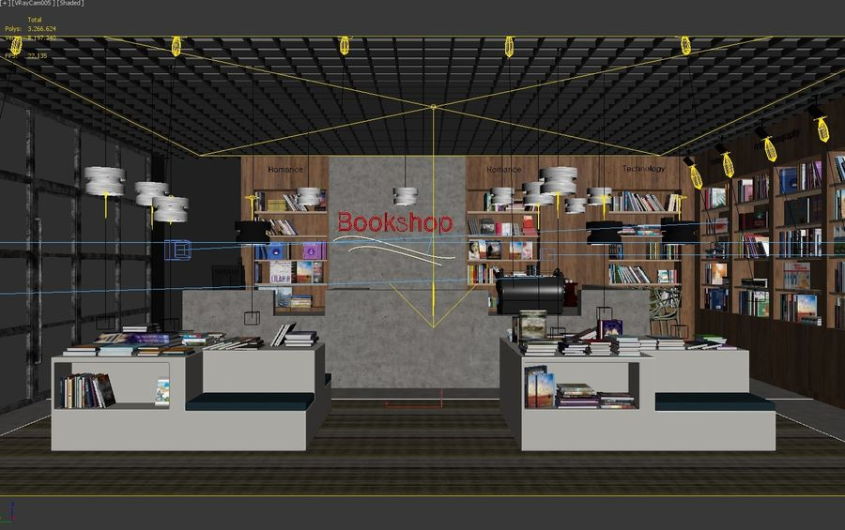

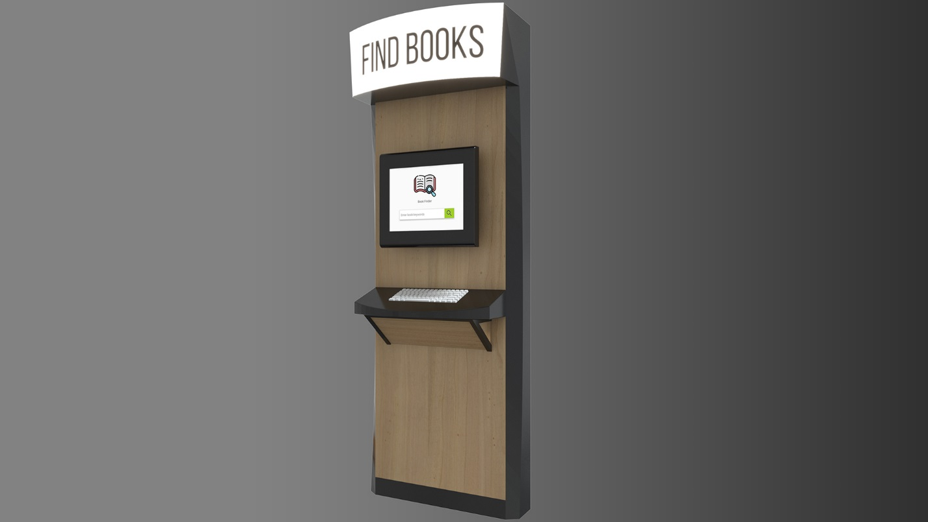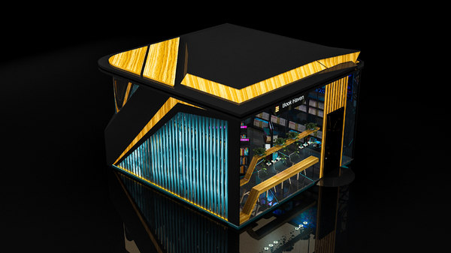

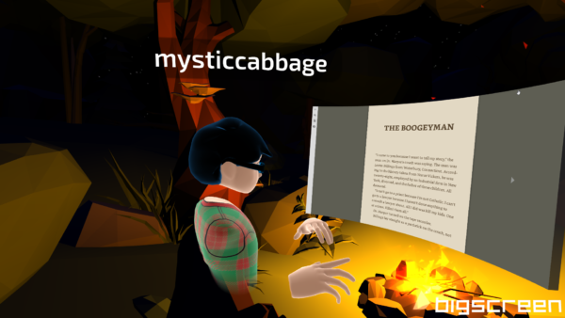

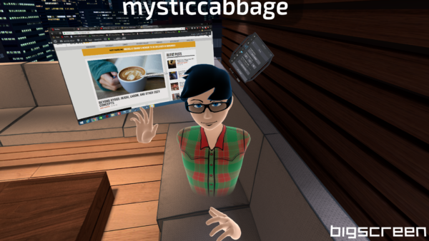

**MVP customer interview Minimal viable product (MVP)**

An MVP (Minimum viable product) is a basic, launchable version of the product that supports minimal yet must-have features (which define its value proposition). An MVP is created with an intent to enable faster time to market, attract early adopters, and achieve product-market fit from early on.

Once the MVP is launched, initial feedback is awaited. Based on this feedback, the company will reiterate to fix the bugs and introduce new features that those early adopters suggest.

The MVP approach allows for:

* Making an early market entry which leads to a competitive advantage
* Enabling early testing of the idea with actual users to check whether the product is able to solve their problems efficiently
* Working effectively towards developing a fully-fledged product that integrates user feedback and suggestions

What is the MVP Development Process?

Minimum Viable Product (MVP), is exactly what it says on the label: the product in its smallest, least featureful avatar. An MVP has just the basic functionalities that demonstrate the product and its ability to solve a user problem. Eric Ries defines it in the following way:

Minimum Viable Product is that version of a new product that allows a team to collect the maximum amount of validated learning about customers with the least effort.

In [mobile app development](https://www.netsolutions.com/mobile-app-development), MVP is a basic version of a mobile application. MVP is a process of building a new product with core functionalities and important, minimum features, to test how the target audience would respond. Then, the building of the actual product takes place with the full set of features after a series of iterations, with feedback from early adopters.

**P.S.**– It is building a slice across the whole development process rather than one layer at a time.

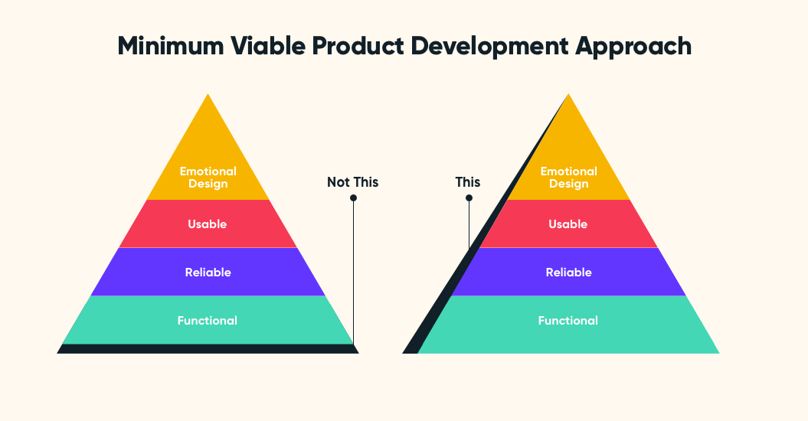

MVP helps in testing, designing, and delivering the final product. MVP Development plays an important role in web development and designing. Several businesses have pitfalls while trying to launch a Minimum Viable Product for a mobile or web app. That’s why it is important to understand the vital question: what is the best way to develop a Minimum Viable Product?

Design and implementation The app is specifically designed for reading/listening to stories, creating distractionfree moments dedicated to this activity. For this reason, the user experience and interface have been designed with purpose-driven limitations. It is a seated experience with movements limited to 3-degrees-of-freedom, no interaction with the physical environment is possible, and the user interface (UI) is intuitive and requires only a few clicks to start reading/listening to the story. 4.1 User Interface The UI is a non-diegetic panel in which users can choose an environment and a text/audiobook from two menus (Fig. 1). The panel with the two menus can be accessed by clicking on a 3D object floating in the scene (spatial interface), a closed old book that opens and reveals the panel. Users can pause the audiobook, change background scene and activate/deactivate the audio reverb (see below). By clicking again on the 3D book the panel disappears. Fig. 1. Home scene with user interface for the selection of story and environment. 4.2 Graphics A series of environments have been designed and manually modelled in 3D with the aim of creating an atmosphere that can help to focus on the reading experience and increase the absorption in the story by matching the environment with the story’s theme or atmosphere. The home environment is a mysterious wooden library, in which users are surrounded by books. Here they can select a story or poem and one of four different environments (Fig. 2), designed to offer visual and audio stimuli that will be ”peripherally perceived” during reading/listening, thus supporting imagery and transportation into the story world [16]. The scenes do not represent the story content, therefore we believe they will not be an impediment for imagination, since users will still be able to picture

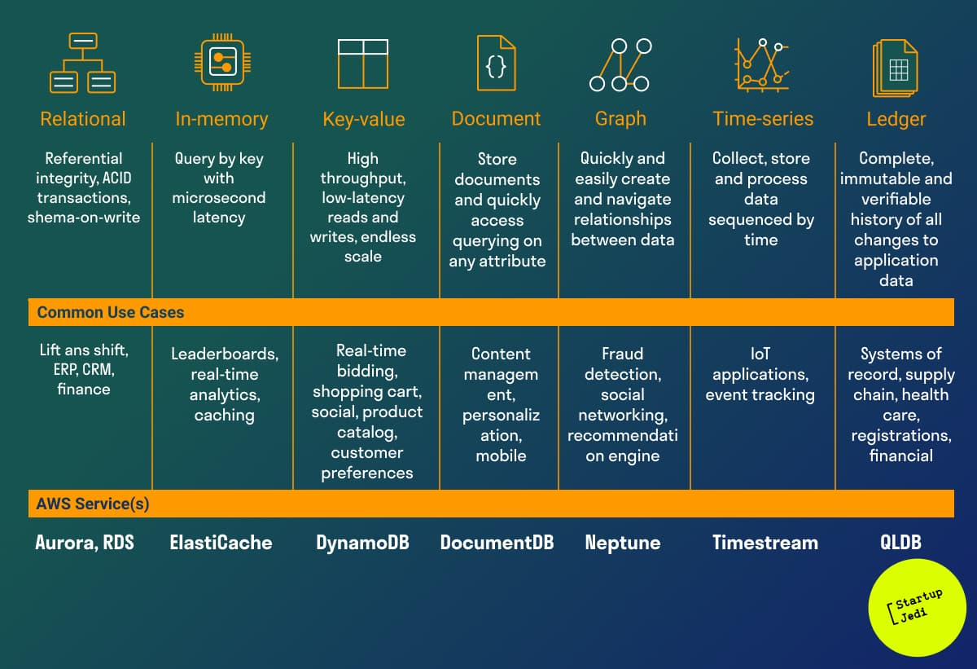

**History:**

**Sometime in the early 1990s, Jeff Bezos read a report on the future of the Internet that predicted 2300% annual growth in Internet commerce. Bezos compiled a list of twenty products that could be sold online. He narrowed the list down to five of the most promising products, including: compactness.**

**disks, computer hardware, computer software, videos and books. In the end, Bezos decided that his new business would sell books on the Internet due to the large global demand for literature, low book prices, and the sheer volume of publications available in print.**

**Thus, Amazon was founded in the garage of Bezos' rented home in Bellevue, Washington. The site was very simple: just a catalog of books. If a customer ordered one, Amazon would buy it directly from the distributor and ship it. In true minimum viable spirit, they kept repeating it. They made it better and better and better, each time lowering costs and increasing profitability. Each time, delighting more and more customers. Getting bigger and bigger each time.**

**Over the years, Amazon began selling more products, buying warehouses, and personalizing its website for every visitor. Amazon is now the largest retailer in the world, according to Forbes.**